Full name
Email address
Button Get started
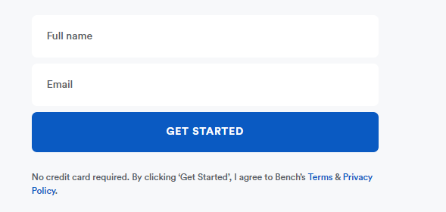

Company Size( drop down )
Monthly Revenue (drop down )
Last Tax Return (drop down )

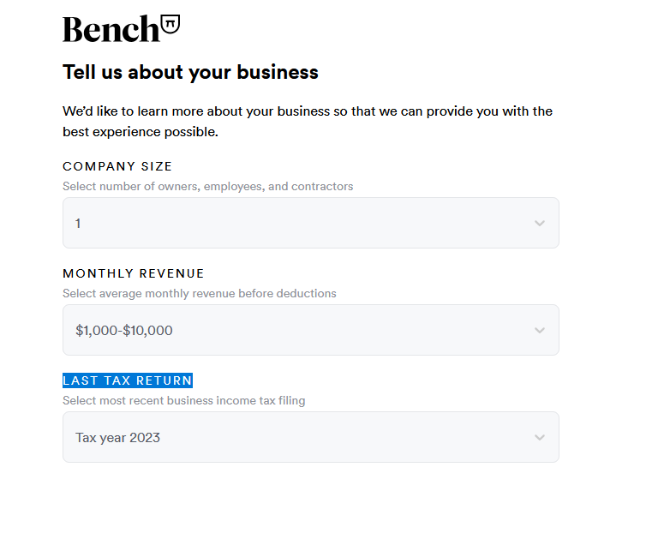

Company Name input fields
Mobile Number
Country (drop down )
Time zone ( drop down )
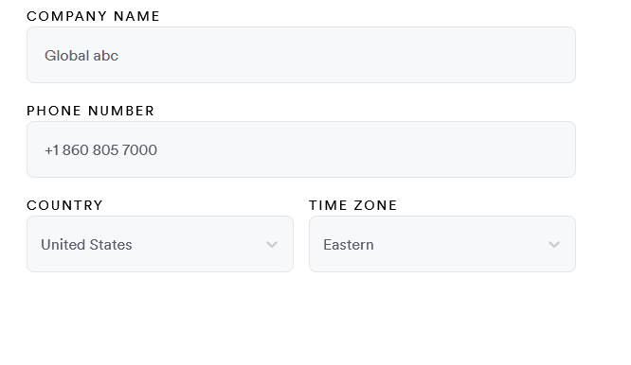
First Name
Last Name
Email
Password
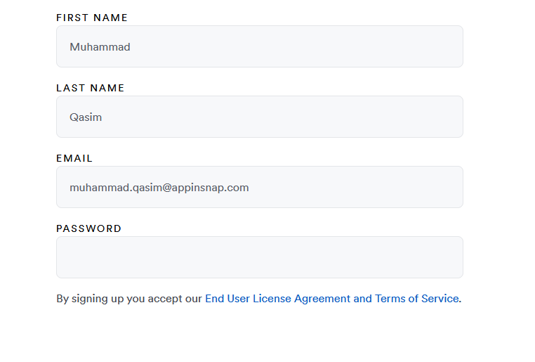
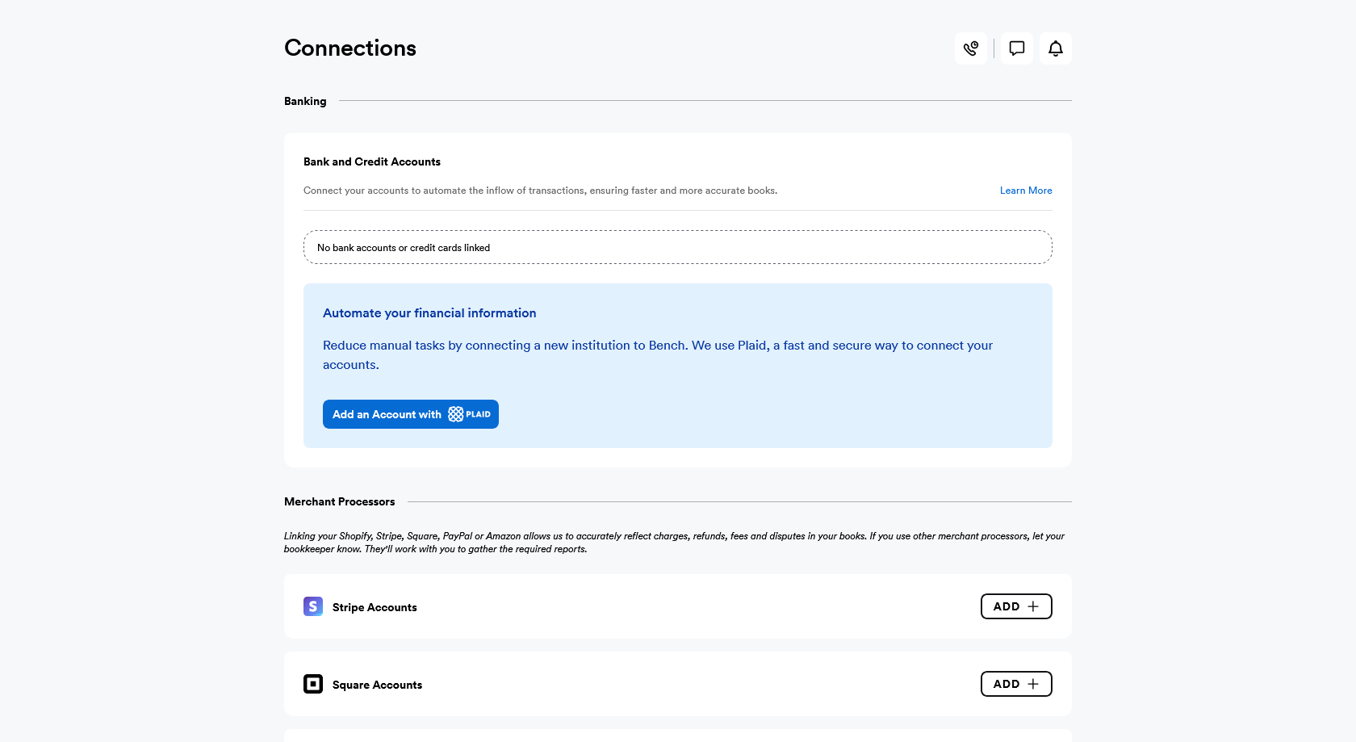

Connect your bank with bench after login
